**Servomótor RG996R**

Have a look at the specs for your servo. It will expect to see a pulse every 20mS or so. The duration of the pulse will determine the angle. **N.B. This 20mS timing may vary depending on the servo type used**. The length of the pulse within this time will determine the position (min about 1ms, max about 2mS) 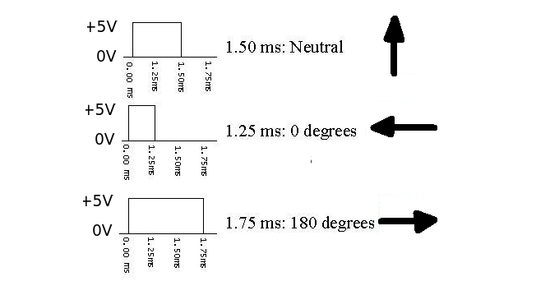

The three connection wires are Power (+5V), Control Signal and Ground. Check the maker for specific colour code. Test the servo is working by setting up a 1.25mS pulse (0 - 5 - 0) every 20 mS. The arm should swing to the 0 degree position. Then change the pulse length to 1.75 mS and the arm should swing to 180 degrees. Putting a constant high signal on the input is not recommended.

As regards testing the output you could try a high impedance speaker (>64R) connected in series with a small capacitor (say 0.1 uF). connect one side to ground and the other to a probe (piece of wire). You should hear a low frequency hum if the output line is switching on and off.

